**NEW HORIZON COLLEGE OF ENGINEERING**

**DEPARTMENT OF COMPUTER SCIENCE AND ENGINEERING.**

**BIO INSPIRED DESIGN AND INNOVATION (22BIK36)**

**REPORT 1**

**THIRD SEMESTER YEAR: 2024-2025.**

**NAME:** Ashmitha Suma Raj

**USN:** 1NH24CS402-T

**SEMESTER: 3rd sem**

**SECTION: C**

**SUBMITTED TO: Shiva Prakash S**

**DATE:**

**____________________________**

**FACULTY SIGNATURE.**

**TOPIC:**  BIOMMICRY FOR VACCINE STORAGE: A NATURE INSPIRED SOLUTION.

**ABSTRACT:** Our goal is to develop a vaccine storage method that can overcome the traditional refrigeration method to store vaccines in a regulated temperature that is suitable for vaccines in remote area.

To achieve our objective we implement the Bio-mimicry process to solve the problem and get the required solution.

**INTRODUCTION TO OUR TOPIC:**

The global need for effective vaccine storage has prompted researchers to explore alternative methods that can overcome the limitations of traditional refrigeration. Bio-mimicry, the practice of learning from nature to solve human challenges, offers a promising approach.

**GOAL:** Develop a vaccine storage method that maintains potency without refrigeration.

**OBSTACLE:** Vaccines require specific temperature ranges, which are difficult to maintain in remote areas.

**UN SUSTINABLE GOAL:** Good Health and Well Being.



**REVIEW / LIT SURVEY:**

**LATEST REVIEW UPDATES:**

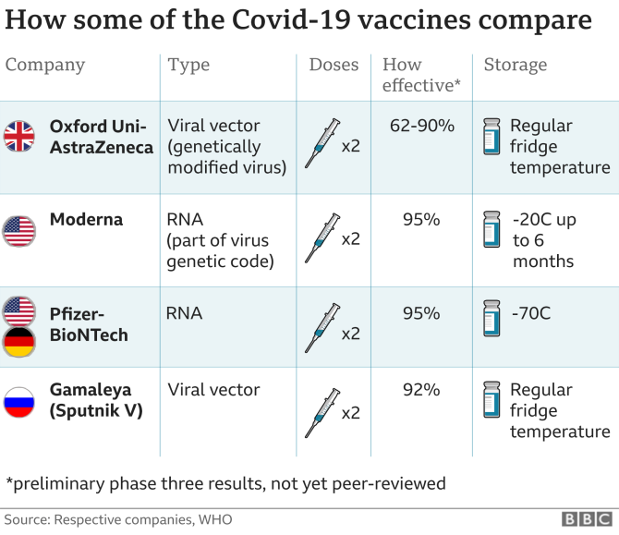

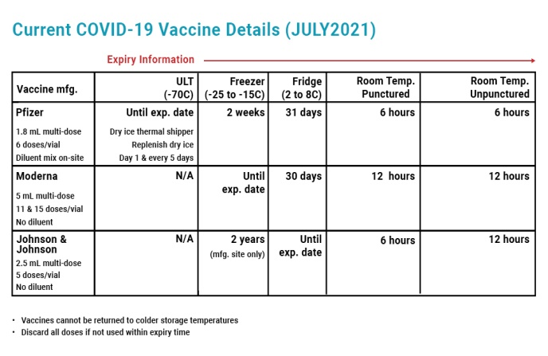

**PROBLEM STATEMENT:**

Our problem statement is to create a vaccine storage method rather than the traditional refrigeration method that can be used in remote areas where the refrigeration technique cannot be implemented due to certain economical or other environmental condition.

**CONTENTS:**

We followed the Bio-Mimicry process cycle that include:

* Define our Objective
* Biologize the challenge
* Discover
* Abstract
* Emulate
* Evaluate.

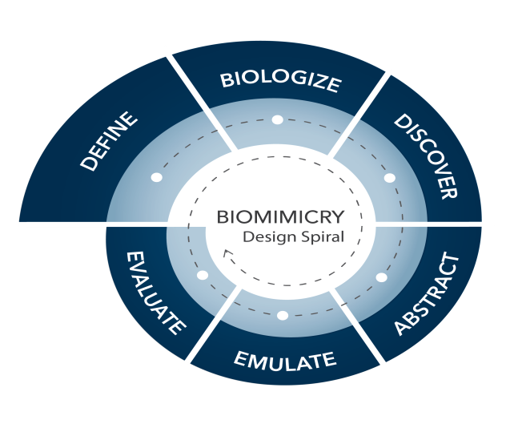

**PROPOSED METHOD:**

We biologize the challenges to implement it through nature inspired solution.

**Method 1:**

The first method we implement is **Tardigrades Cryptobiosis Method.** This method implies that Tardigrades can survive extreme temperature by entering this state called Cryptobiosis where they dehydrate and conserve metabolic rates where they tend to minimize the damage caused to the vaccine as the result of longer storage without refrigeration.

**Method 2:**

The second method we implement is **Desert Beetles Micro packaging Method.** This method implies that Desert Beetles evolve efficient mechanism to store moisture in arid environments by regulating temperature fluctuations by preventing dehydration and maintain stability that refer to contiguous properties of vaccine when they are stored for long period of time without proper refrigeration.

**Method 3:**

The third method we implement is **Seeds Sugar Based Stabilizers.** This method implies that Seeds utilize proteins and sugar like trehalose that maintain viability for extended periods in dry conditions to stabilize cellular structure during stress that maintains sensitive components during vaccine storage for prolong period of time.

**RESULT & DISSCUSION:**

After implementing all the nature acquired solutions we test the vaccine to satisfy all the user required solutions like:

* Conducting laboratory tests to evaluate the effectiveness of stabilizing agents in preserving vaccine potency.
* Access durability, cost-effectiveness, transportation and bio-mimicry inspired packaging according to climate conditions.
* To refine storage method based on test result, optimizing performance, ease of use and scalability as needed.

**CONCLUSION:**

We thereby implemented the nature’s solution to store vaccine and according to our goal and objective that is more effective than the traditional method of storage, which results in successive implementation of the methods we discussed as above.

**REFERENCES:**

[*https://www.learnbiomimicry.com/blog/best-biomimicry-examples(Learn Biomimicry. Com)*](https://www.learnbiomimicry.com/blog/best-biomimicry-examples(Learn%20Biomimicry.%20Com)%20)